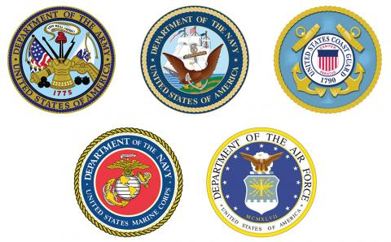
Women Air Corps (WAC)
Women Auxiliary Air Corps (WAAC)
Women Accepted for Volunteer Emergency Service (WAVES)
Marine Corps Women Reserves (MCWR)
USCG Women Reserves( SPARS)
Women Air Force Service Pilot (WASP)
Nurse Corps (NC)
19 March 2018

To All Veterans & Friends of Veterans,

To celebrate the 100th anniversary of military women veterans, the Connecticut Veterans Service Organizations are planning to host an awards ceremony, celebrating and honoring all World War II women Veterans.

We are asking for support in locating and identifying those women who served as part of the United States military during WWII. The attached flyer provides information on this upcoming event. Please share this information and the flyer with your network, friends, and family as well as your social media contacts. Also attached is a very important application for the Connecticut Veterans Wartime Service Medal and/or Connecticut Service members and Veterans Registry Application. If possible, help her complete the application with any supporting documentation and return this form to the Connecticut Department of Veterans’ Affairs at the address on the instructions page.

These WWII veterans are all in their 90’s and it is imperative that we be aggressive at identifying our women veterans by April 22, 2018 application deadline. The date, time and place for the impending ceremony will be announced later.

Please help us honor our Connecticut Women Veterans during this 100th anniversary year. Your support is greatly appreciated. Any questions, please feel free to call Jamie DePaola at
860-985-2064 or Sal Sena, Sr. at 860-614-6188.

Respectfully,

Sal V. Sena Sr.
Marine Corps Heritage Foundation
CT State Liaison - Governors Council
Dept. of CT Marine Corps League
Public Relations Officer
860-614-6188
4mermarine69@gmail.com

WWII Women’s Honor Committee

Lynette Adams, PHD VA Women Veteran Program Manager
John “Jack” Casey USN Past State Capt. Patriot Riders
Jamie DePaola USMC Director Women Marine Assoc.
Dana Dillon USAF Past State Comm. Am Vet., Senior Vice Jewish War Vets
Elliot Donn USN Jewish War Vets
Emily Hein USA CT VA
Adele Hodges USMC CT. Senior Vice Cmdt. Marine Corps League
Tammy Marzik CT VA
Lori Marriott Easter Seals Capital Region & Eastern CT
Ryan McKenna USA VA Manager Office of Advocacy and Assistance
Beth Pritchard Senior Vice Pres. Easter Seals Capital Region & Eastern CT
Dennis Salzer USN Am Vets & American Legion
Tom Shields USA Dept. Comm. American Legion
Gary Wallace USN Post 75 American Legion

