***On Sale at the Troop 1 bus Xmas Tree Sale: Fritz's Parking Lot***

***Also at:*** **Oxford Lumber    
 Oxford Town Hall - clerk's office**

**Oxford Pharmacy**

***$10 each***

***‘Chelsea’s Ornament’***

***Designed by: Wendy Anderson   •   Cr****afte****d by: Woodbury Pewter***

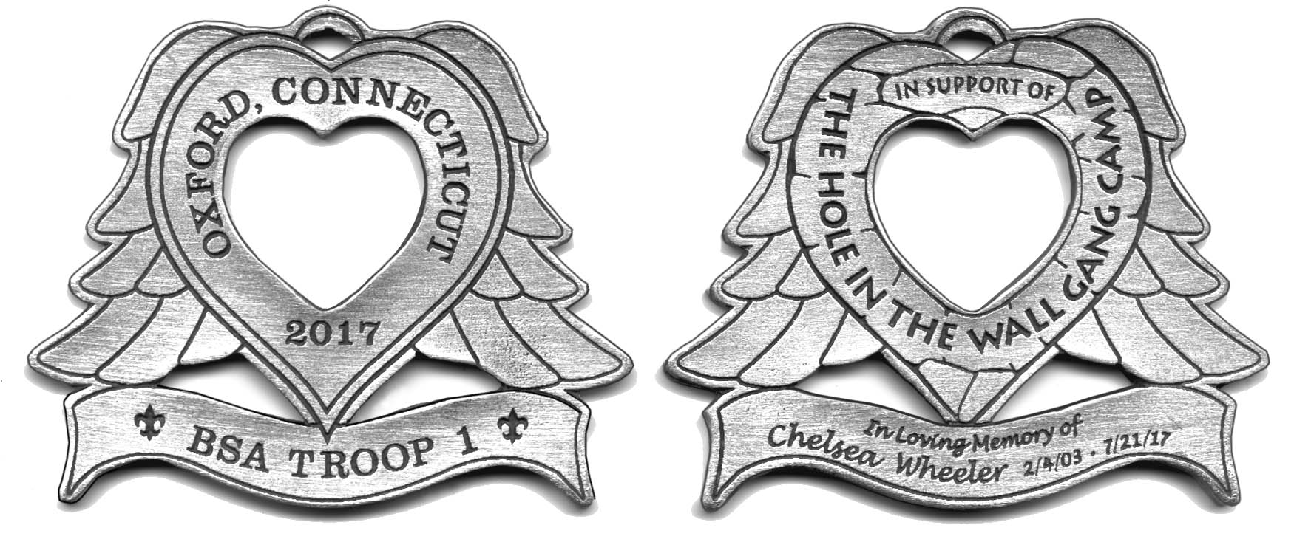

***BSA Troop 1 • Thanks You For Your Support***

**This year the proceeds will be donated to   
         The Hole in the Wall Gang Camp  
*In honor and memory of Chelsea Wheeler***

Founded in 1988 by Paul Newman, The Hole in the Wall Gang Camp provides “a different kind of healing” to more than 20,000 seriously ill children and family members annually - all completely free of charge. For many of these families, Hole in the Wall provides multiple Camp experiences throughout the year at the facility in Ashford, Conn., in more than 40 hospitals and clinics, directly in camper homes and communities, and through other outreach activities across the Northeast.



**Make Checks Payable to: Troop 1 Oxford**

**OXFORD**

**TROOP 1 ORNAMENT**

**2017**

